Brian Engel

Project 2

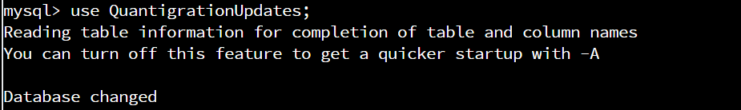

use QuantigrationUpdates;

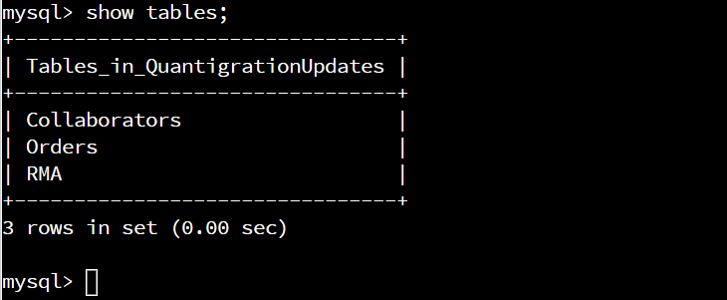

show tables;

Switch to QuantigrationUpdates database and shows tables in it.

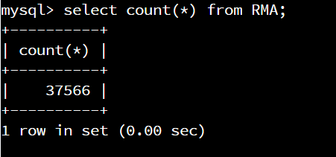

Command: select count(*) from RMA;

Get the total amount of returns at 37566.

* **Analyze** the **number of returns** **by state** and describe your findings in your report.

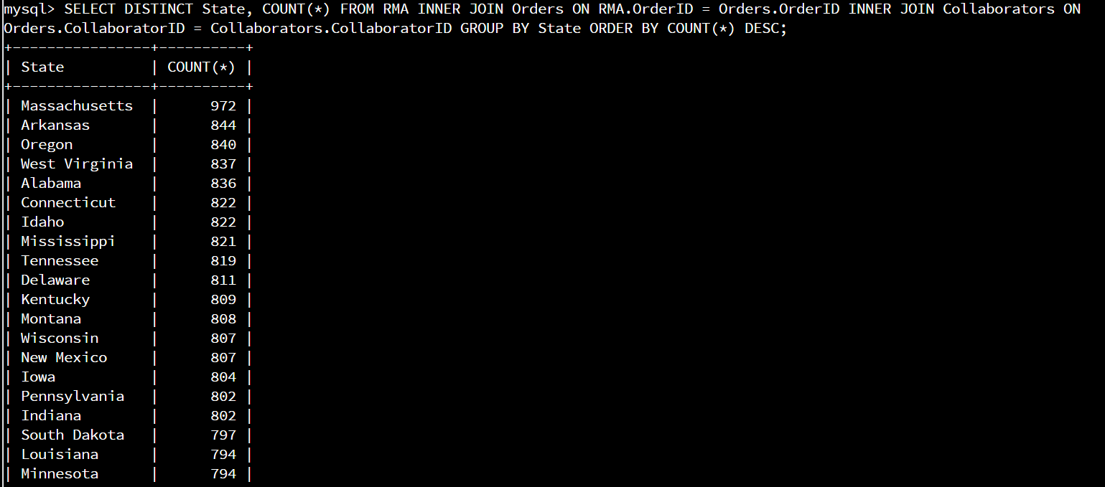

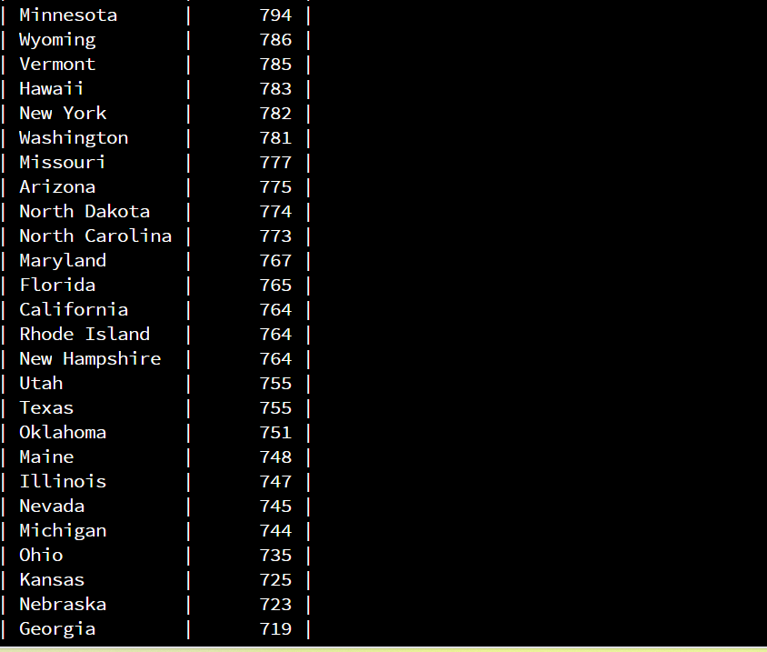

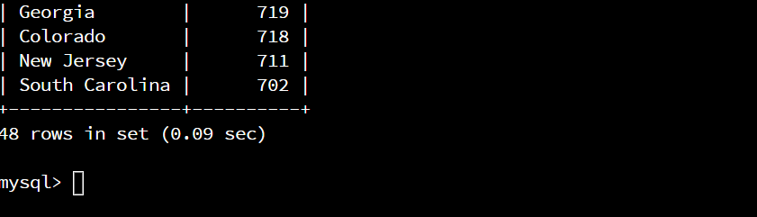

Command: SELECT DISTINCT State, COUNT(*) FROM RMA INNER JOIN Orders ON RMA.OrderID = Orders.OrderID INNER JOIN Collaborators ON Orders.CollaboratorID = Collaborators.CollaboratorID GROUP BY State ORDER BY COUNT(*) DESC;

Massachusetts has more returns than any other state with 972. All the other states are fairly close in returns with numbers between 844 and 702.

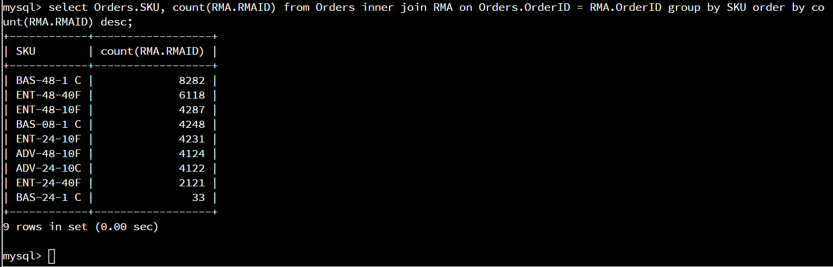

Command: select Orders.SKU, count(RMA.RMAID) from Orders inner join RMA on Orders.OrderID = RMA.OrderID group by SKU order by count(RMA.RMAID) desc;

It looks like model BAS-48-1 C had the most returns by far at 8282, ENT-48-40F had the second most at 6118, and ENT-48-10F had the third most at 4287.

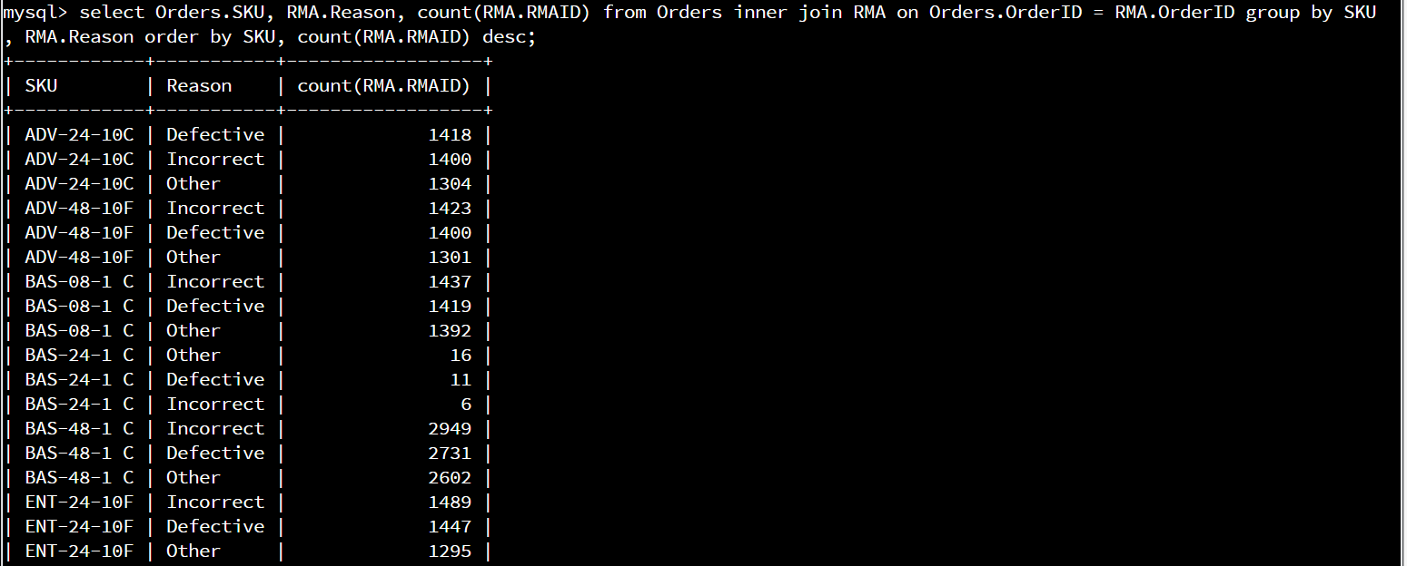

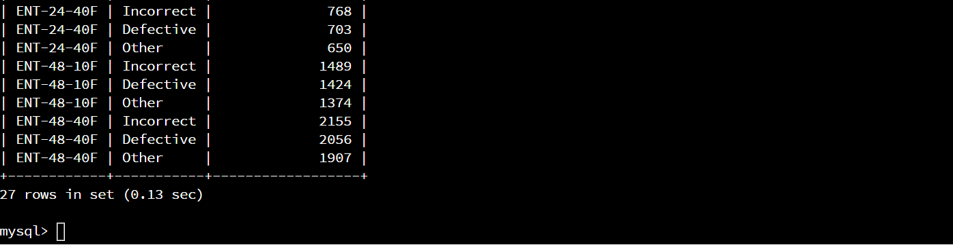

Command: select Orders.SKU, RMA.Reason, count(RMA.RMAID) from Orders inner join RMA on Orders.OrderID = RMA.OrderID group by SKU, RMA.Reason order by SKU, count(RMA.RMAID) desc;

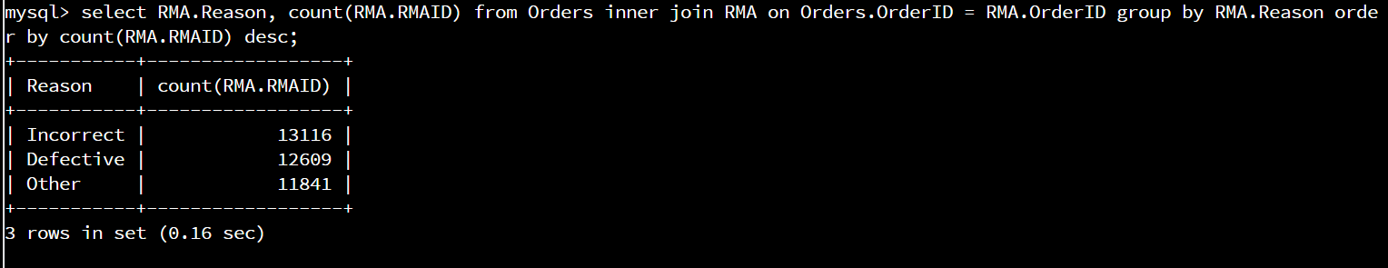

select RMA.Reason, count(RMA.RMAID) from Orders inner join RMA on Orders.OrderID = RMA.OrderID group by RMA.Reason order by count(RMA.RMAID) desc;

It looks like the reason for the most returns was the part was incorrect at 13116, defective part was second at 12609, and other was the third reason at 11841.

The state with the most returns is Massachusetts with 972. This could be because Massachusetts has the highest number of sales, or because it has a higher percentage of returns. I can't distinguish between the two without the actual sales figures instead of just the sales that were returned, unless all the sales were returned, which I doubt. The other states had similar return figures with between 844 and 702, obviously disregarding the fact I don’t have the actual sales figures so the percentages might differ a lot even while the actual numbers don't.

BAS-48-1 C had the most returns of all the products with 8282, ENT-48-40F had the second most at 6118, and ENT-48-10F had the third most at 4287. The rest of the products were right in line with the third product, apart from ENT-24-40F with half that amount, and BAS-24-1 C with a total of 33. These numbers, once again, are hard to give any meaningful analysis without knowing how many were sold total. I would assume that the more returns there are, the more were sold in the first place, and the one with only 33 returns might just be a new product.

Looking at the breakdown of why products were returned, it seems that the reasons of incorrect (13116), defective (12609), and other (11841) are all close in number, both on the individual products and as a total. It seems that returns on the incorrect part could probably be lessened by maybe updating the order guide or some other form of educating the consumer on what parts they need.